Name : Farne, Jian Ira Olvido
UOWID : 7433546
Assignment : 01
Document : Word Document Report
- Introduction
In this report, I will discuss how I structured and implemented the Weather Information Processing and how the foundation of the code relates to procedural programming, control structures, arrays, dynamic memory allocation, and input/output. The WIPS is coded with C++ program that offers weather data management and analysis capabilities.
- Overview
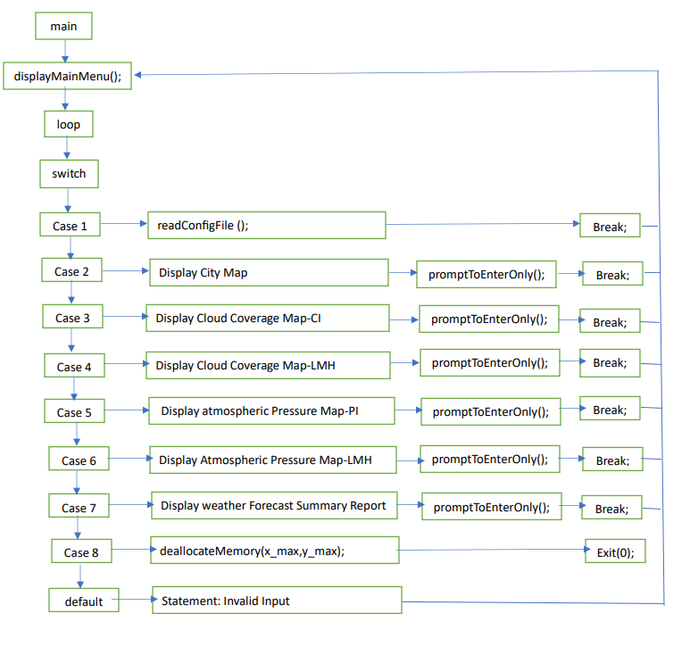
The project is designed to read and process a configuration file that contains information about a 2D map, city locations, cloud cover, and pressure data. The implementation uses C++ and employs various data structures and functions to achieve the desired functionality. It utilizes two structs, one for each location of the 2D map and another for the relevant information of a city. The structs are initialized to nullptr to avoid memory issues.

The `splitString` function is used to split strings based on a specified delimiter. It helps parse the contents of the configuration file effectively. The program then reads and processes the config file, ignoring comments and empty lines. The extracted information, such as GridX_IdxRange, GridY_IdxRange, citylocation.txt, cloudcover.txt, and pressure.txt, is stored in relevant variables.

The code initializes a 2D array to represent the map and initializes city information using pointers. Sorting of X and Y values is done to facilitate easy insertion of elements in the city summary struct. The method `insertCityID` ensures uniqueness of city IDs to avoid duplication when displaying city summaries.

The program offers a menu-based interface to display city maps, cloud coverage maps (index/LMH), and pressure coverage maps (index/LMH) based on user input. Cloud and pressure indexes are calculated, and corresponding symbols (LMH) are retrieved for display.

Finally, a summary report of the weather forecast is generated, displaying total cloud cover and pressure for each city, along with their averages. A locking mechanism ensures the user enters the config filename (option 1) before accessing other functionalities.

Overall, the implementation provides a well-structured and efficient solution to read and process the configuration file, display weather forecasts, and manage user input effectively.
- Reflections

Throughout the process of designing and coding the program, I learned some valuable lessons in C++ programming. Initially, I had separate functions for displaying city info, cloudiness index, and pressure index. But then I realized that there was a lot of repetition in those functions, so I decided to refactor them into one function using an if-else statement to handle different user inputs. This made my code look cleaner and more organized, and it also made it easier to add new features later on.

I also learned about memory management, which is super important when dealing with pointers. It's crucial to allocate memory properly and free it when it's no longer needed. So, I made sure to use the `clear()` method for vectors and `shrink_to_fit()` function to release resources. This helped avoid memory leaks and made my program more reliable and efficient.

Another thing I learned was how to handle file operations correctly. It's essential to close files after reading or writing data to release resources and let the operating system know that you're done with the file. By doing this, I prevented potential issues and made my program run smoother. Overall, I feel like I've grown a lot as a C++ programmer through this project, and I'm excited to apply these skills to future assignments and projects.

- Problems
The file can only be compiled and executed through windows. I tried countless times in UBUNTU but couldn’t figure out what the error was. I just couldn’t make any sense of it because the windows compilation shows no error much less in running it.

